“Full Uniform with Pride'' Policy

RATIONALE

The uniform exemplifies students’ pride in being part of the Aspley Special School Community. There is a
belief that having all students wear a school uniform helps create a sense of belonging and a good school
ethos (culture or spirit). By showing that we expect high standards with our uniform, expectations are
raised and students respond with better behaviour. The students, parents and staff of this school believe
that the Dress Code requirement is important in developing a sense of identity and pride for our students.

PURPOSE

We believe that the wearing of correct school dress allows each student to identify with the school, builds
group spirit and prevents discrimination, unhealthy competition and arguments at home.

‘WITH PRIDE’

The uniform must be worn in a responsible and respectful manner and must be maintained in good order
i.e. clean and in good repair.

REPRESENTING OFF SCHOOL SITE

It is imperative that all students adhere to the ‘Full Uniform with Pride Policy’, including correct hat at
all excursions, sporting and cultural events.

RESPONSIBILITIES

PRINCIPAL

- Ensure that the Aspley Special School Dress Code is consistent with relevant legislation, both State and Commonwealth.
- Ensure that processes and sanctions are clearly articulated and are inclusive of special circumstances and particular students.
- Liaise with the P&C to ensure the ‘Full Uniform with Pride’ Policy is supported and endorsed by the parent body.
- Liaise with the P&C Uniform Shop committee to ensure that sufficient and appropriate uniform stock is available to support ‘Full Uniform with Pride’ Policy.
- Consult with parents or carers of children enrolled at their school, school staff and students to develop the ‘Full Uniform with Pride’ Policy.
- Provide communication to parents re serious concerns about a student who does not comply with full school uniform.

PARENT / CARER

We recognise and thank the community and parents for their support of the Aspley Special School
‘Full Uniform with Pride’ Policy.

- Compliance with the school policy is an expectation of enrolment at this school.
- Support students to comply with all aspects of the Aspley Special School ‘Full Uniform with Pride’.
- Support the school in their endeavours to promote a Full Uniform with Pride Policy.

STUDENT

- Wear the full school uniform correctly to, from and during school each day.
- Assist parents / caregivers to ensure you meet with all aspects of the policy.
- Comply with staff directions at all times in regards to the policy.

UNIFORM

Our uniform consists of the following:

School uniform

- Navy polo shirt, or Polo Shirt with the School Emblem - are to be worn.
- Navy unisex shorts, navy skirt/skort..
- Bike pants/leggings may be worn under dress for comfort but not as a replacement for shorts/skorts.
- Navy wide brimmed hat must be worn, or the School Cap.

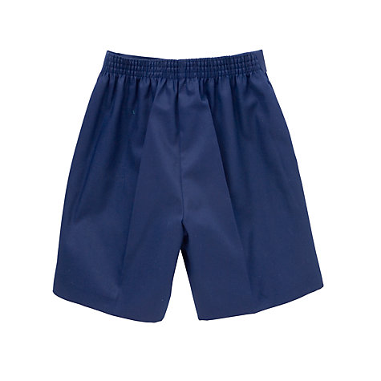
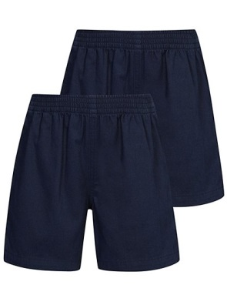
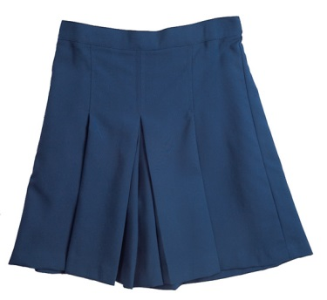

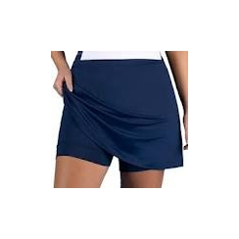

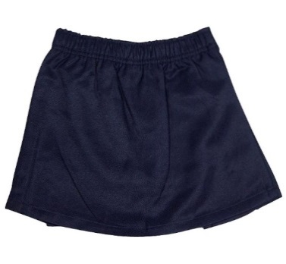

Winter

- Navy jacket with Aspley Logo, or plain navy jacket
- Plain navy track pants / bootlegs
- Plain navy sweat shirt or jumper
- Navy tights for winter

Foot wear

- Solid Black leather shoes or joggers/sneakers with laces or Velcro or a buckle. No bright laces or logos.
- For new students, the colour black can be introduced as children require a new pair of shoes.
- Plain white socks are to be worn – No colour bands or logos.
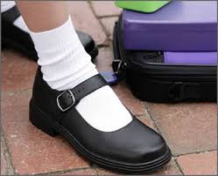
- Members of the choir and School leaders are expected to wear black shoes and white socks.

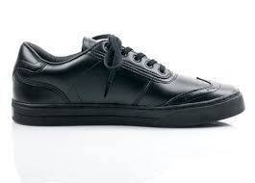

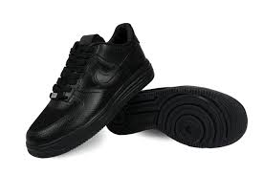
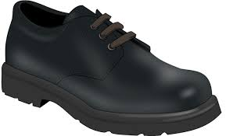

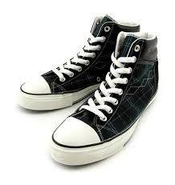

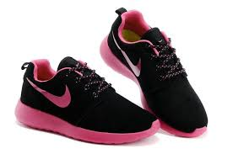

Sports Uniform

Each sports house has its own polo shirt which is to be worn:

- for any inter-house activity

It must not be worn when leaving the school on an excursion or special occasion. A regular school shirt
must be worn for these occasions.

- Moobunga- Red
- Waarnyland - Yellow
- Spinapoonia - Blue

HAIRSTYLES

Our uniform is complimented by a tidy appearance:

- Hair should be neatly groomed and kept out of the eyes.
- Shoulder length or longer hair should be kept tied back from the face.
- Extremes of hair styles or hair colours are not acceptable.
- Hair clips and head bands should be in school colours, black or white.

JEWELLERY

Certain jewellery will not be allowed for the following reasons:

- For safety reasons
- Students become very distressed when they lose or break jewellery.
- Jewellery can also be an item that is a fashion statement or can cause inequity amongst the students.

If jewellery is worn to school the following dress codes should be complied with:

- In the interest of safety, earrings should be of the small sleeper or stud variety. They are to be minimal and inconspicuous.
- In the interest of safety, piercing to be in each ear only.
- In the interest of safety, chains, rings, necklaces, bracelets, wrist bands (this includes hairbands worn around the wrist) and anklets are not be worn as they can cause an injury.
- Medic-alert bracelet/necklace is of course acceptable.
- Wrist watches can be worn.

MAKEUP

Make-up, unless for documented medical reasons, is not acceptable therefore no nail polish or makeup to
be worn at school.

MODIFICATION TO THE DRESS CODE

Parents of students who for religious, cultural or health reasons may need to modify the school dress code
are required to make an appointment with the Principal. Staff members will be informed of any student
granted a modification to the dress code.

For unforseen problems that may arise of a morning could you write a note to the teacher explaining the
temporary replacement of the lost or damaged uniform item.

FREE DRESS POLICY

In the event of a free dress day, appropriate clothing must be worn.

- Shirts or dresses which expose the midriff, cleavage, or bare shoulders, must not be worn.
- Broad brimmed hat must be worn.
- In the interest of safety closed in shoes must be worn.
- Shirts and dresses must have sleeves.
- No inappropriate words or pictures on garments.
- Dresses/skirts/shorts must be a reasonable length.
- Exposure of undergarments is not permitted.
- Bike shorts or leggings must not be worn with brief shirt.

CONSEQUENCES FOR NOT BEING IN UNIFORM:

- Assistance/support will be given to obtain suitable clothing if necessary.
- Students will be counselled by the Principal or Principal's nominee on the benefits of a dress code.
- The Parents/Carer will be contacted by the Principal whereby parents will be asked to assist in following the dress code.
- In the case of makeup and nail polish, the children will be asked to remove it where the office will have non allergenic remover for the student to use.
- In the case of jewellery the student will be asked to remove it and place in their bag. If it is a valuable piece it will be kept in the office for them to collect at 3.00 pm.
- No hat – No play!

PERSISTENT STUDENT NON-COMPLIANCE WILL RESULT IN:

- Parents contacted by Admin to inform them of concerns.
- Prevention from attending or participating in any activity for which the student would have been representing the school. This includes interschool sport. All students representing the school at an interschool sporting game are expected to wear the complete sports uniform, including the correct hat.
- Time out

Student Signature:_______________________________________

Parent Signature:________________________________________

