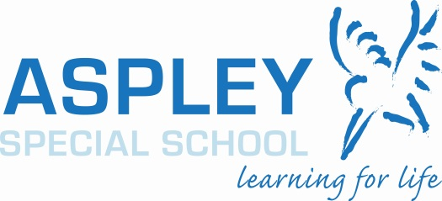

Responsible Behaviour Plan for Students

- Purpose

Aspley Special School is committed to providing a safe, respectful and disciplined learning environment for students and staff, where students have opportunities to engage in quality learning experiences and acquire values supportive of their lifelong wellbeing.

This Responsible Behaviour Plan for Students is designed to facilitate high standards of behaviour so that the learning and teaching in our school can be effective. It is also designed to enable students to participate positively within our school community.

- Consultation and data review

Whole school and community consultation about the previous Responsible Behaviour Plan for Students was part of the Quadrennial School Review process. Consultation, discussion and modification of the Plan is a core component of the School Wide Positive Behaviour Support (SWPBS) Committee meetings. The School Wide Positive Behaviour Support Committee has representation of school, parent/carer and community members.

- Learning and behaviour statement

All areas of Aspley Special School are learning and teaching environments. We consider behaviour management to be an opportunity for valuable social learning as well as a means of maximising the success of academic education programs.

Aspley Special School’s Responsible Behaviour Plan outlines our system for facilitating positive behaviours, preventing problem behaviour and responding to unacceptable behaviours. Through our school plan, shared expectations for student behaviour are plain to everyone, assisting Aspley Special School to create and maintain a positive, productive learning environment. All school community members have clear, consistent expectations and understandings of their role in the educational process.

Aspley Special School’s school community has identified the following school rules to teach and promote our high standards of responsible behaviour:-
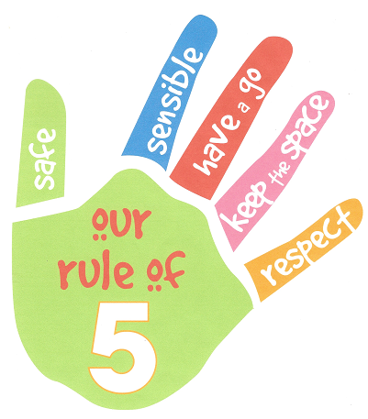

  - Be safe
  - Be sensible
  - Have a go
  - Keep the distance
  - Be respectful – to self, others and property
Aspley Special School’s rules have been agreed upon and endorsed by all staff and the Parents’ and Citizens’ Association (P&C). They are aligned with the values, principles and expected standards outlined in Education Queensland’s Code of School Behaviour.

- Processes for facilitating standards of positive behaviour and responding to unacceptable behaviour

Aspley Special School has adopted a whole school approach that shapes, supports and recognises appropriate behaviours in all students.
This approach of universal, targeted and intensive behaviour support includes:-
- quality learning and teaching practices;
- a balanced, relevant and engaging curriculum;
- supportive and collaboratively developed procedures;
- the implementation of evidence-based programs;
- regular monitoring and review of school procedures and programs;
- professional development for all members of the school community consistent with the school’s evidence based approach to promoting positive behaviour;
- adoption of practices that are non-violent, non-coercive and non-discriminatory; and
- a continuum of whole school positive preventative action for all students.

Continuum of Support
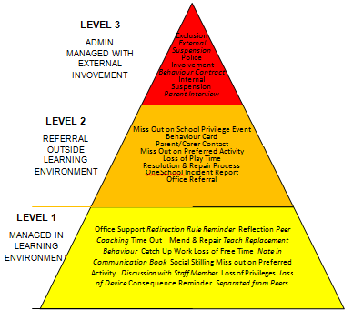

Aspley Special School is currently a Tier 2 School Wide Positive Behaviour Support (SWPBS) school. SWPBS establishes positive preventative and appropriate responsive support strategies. Aspley Special School’s SWPBS approach focuses on behaviour in 5 key areas:-
- whole school systems;
- staff support;
- classroom;
- non-classroom environments; and
- individual students.

This approach sees all staff supporting each student’s behaviour by:-
- acknowledging the uniqueness of each student;
- placing significant emphasis on the development of socially appropriate behaviour;
- recognising that students who feel safe, accepted, supported and valued are more likely to reflect these qualities in their own behaviour;
- emphasising the importance of using teaching strategies which incorporate positive preventative actions; and
- recognising that some students need more help than other students to achieve socially appropriate behaviour and so are committed to a process which develops an individual behaviour support plan for such students.

Universal Behaviour Support

The cornerstone of Aspley Special School’s positive approach to behaviour support is our ‘Rule of 5’. The ‘Rule of 5’ provides the reference point for behavioural expectations, reinforcement and correction.

The first step in facilitating standards of positive behaviour is communicating those standards to all students. At Aspley Special School we emphasise the importance of directly teaching students the behaviours that students should demonstrate at school.

These expectations are communicated through a number of strategies, including:-
- a school wide focus on the Rule of 5 at the beginning of each school year through scheduled behaviour lessons and poster competition;
- clear visual cues displayed in each learning environment (Rule of 5, Matrix, Reward Triangle and Consequence Chart, Area Specific Rules Matrix);
- interacting positively with students means making sure that we accept, value and support each individual student in all of our daily interactions by using non-verbal means (smile, look, gesture) to show our support and acknowledging student difference by using communication methods suited to each individual;
- the Rule of the Week (includes lesson on assembly, micro lessons in form and specialist classes, staff wearing the ‘colour’ of the week);
- rewards for acceptable behaviour (as per the Reward Triangle) such as raffle tickets, High 5 Day, student of the week celebrated at assembly and school electronic sign, recording of positive behaviour on OneSchool;
- parent/carer contact for positive behaviour through communication books, Rule of 5 reward post cards, rule of the week, ‘parent tips’ pamphlets and a dedicated section of the school newsletter and website;
- on an individual and group level as required or when learning and reflection opportunities arise;
- reinforcement of learning from behaviour lessons on school assemblies and during active supervision by staff during classroom and non-classroom activities;
- a matrix of exemplars indicating example positive behaviours and differentiated understanding of the rules within different teaching environments (Area Specific Rules Matrix);
- modelling, video and role play examples of the Rule of 5 in action; and
- anticipating and pre-empting behaviours by taking steps beforehand to ensure that undesired behaviour does not happen eg. fix objects to the work table for a student who is likely to throw them, redirect the student to another activity; remove objects/situations that may distract the student.

Aspley Special School implements the following processes to encourage positive aspirations, relationships and values to develop:-
- explicit school structure and timetabling arrangements that are designed to shape a positive learning environment;
- curriculum selection to suit individual learner needs; and
- staff support through:-
  - daily briefings; daily notices on the team site
  - access to ongoing professional learning, including a focus on the Essential Skills for Classroom Management (ESCM);
  - peer mentoring;
  - Staff Wellbeing Committee;
  - School Behaviour Leadership team members’ regular provision of information to staff and parents, and support to others in sharing successful practices; and
  - Classroom Profiling process utilising coaching designed to build rapport and enhance relationships between students and teachers via a confidential, non-judgmental, voluntary process that enables teachers to reflect on the effective learning and teaching strategies they employ.

Aspley Special School encourages students to take increasing responsibility for their own behaviour and the consequences of their actions by:-
- using Tier 1 and Tier 2 infrastructure to address student behaviours;
- using Tier 2 – targeted interventions to teach specific skills that have been identified through the process to meet the needs of the students;
- displaying and using the Rewards Triangle and system;
- regular review of OneSchool data to identify hot spots and trends;
- developing individual support profiles for students with high behavioural needs, enabling staff to make the necessary adjustments to support these students consistently across all classroom and non-classroom settings; and
- developing specific policies to address:-
  - the use of personal technology devices at School
  - procedures for preventing and responding to incidents of bullying ; and
  - school phone policy.

Targeted behaviour support

Each year a small number of students at Aspley Special School are identified through our data as having at risk behaviours. Aspley is introducing the SWPBS Tier 2 intervention process. This school wide process is team and data driven. It allows for increased adult monitoring, increased opportunities for positive reinforcement, increased practice, continuous progress monitoring, and access to expertise. This process aims to reduce the current cases of problem behaviours.
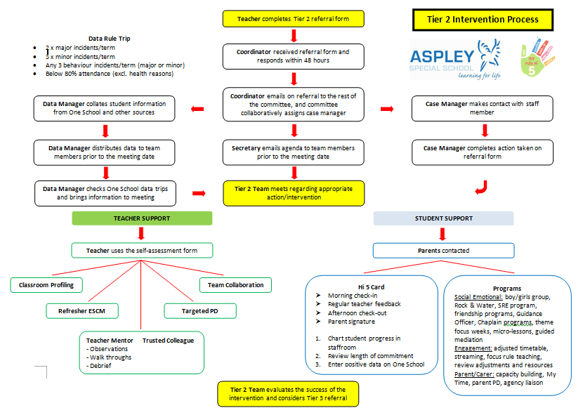

The Tier 2 Intervention process clearly outlines the student and teacher supports that can be put in place to support student behaviour eg. teacher self-reflection, teacher mentoring, classroom profiling, refresher ESCM, targeted PD, check in check out, Rock and Water, Boys/Girls Group, My Time for parents.
Teachers are also able to refer students for intervention

The Tier 2 Team meet to review school wide data and to implement supportive processes as required.

Careful monitoring and evaluation of student progress will indicate when a student is ready to exit from a targeted support program or if the program requires adjustment based on individual student needs.

Intensive behaviour support

Aspley Special School is committed to educating all students, including those with high behavioural support needs. We recognise that students with highly complex and challenging behaviours need comprehensive systems of support.

Aspley Special School is beginning to implement Tier 3 for specialised and individualised systems for students with chronic high risk behaviour. The Tier 3 team focuses on:
- Individual Behaviour Support Plan (IBSP)
- Functional Behaviour Assessment (FBA)
- Building Family Capacity and Resilience
- External Supports
- “Wrap Around” Support

The standing Tier 3 team members include a member from administration, a teacher and a teacher aide as well as ad hoc team members of staff and professionals who know students well and can add value to support individual students.

5. Emergency responses or critical incidents

It is important that all staff have a consistent understanding of how to respond to emergency situations or critical incidents involving severe problem behaviour. This consistency ensures that appropriate actions are taken to ensure that both students and staff are kept safe.

An emergency situation or critical incident is defined as an occurrence that is sudden, urgent, and usually unexpected, or an occasion requiring immediate action.

Severe problem behaviour is defined as behaviour of such intensity, frequency, or duration that the physical safety of the student or others is likely to be placed in serious jeopardy.

Basic defusing strategies

Avoid escalating the problem behaviour
Avoid shouting, cornering the student, moving into the student’s space, touching or grabbing the student, sudden responses, sarcasm, becoming defensive, communicating anger and frustration through body language.

Maintain calmness, respect and detachment
Model the behaviour you want students to adopt, stay calm and controlled, use a serious measured tone, choose your language carefully, avoid humiliating the student, be matter of fact and avoid responding emotionally.

Approach the student in a non-threatening manner
Move slowly and deliberately toward the problem situation, speak privately to the student/s where possible, speak calmly and respectfully, minimise body language, keep a reasonable distance, establish eye level position, be brief, stay with the agenda, acknowledge cooperation, withdraw if the situation escalates.

Follow through
If the student starts displaying the appropriate behaviour briefly acknowledge their choice and re-direct other students’ attention towards their usual work/activity. If the student continues with the problem behaviour then remind them of the expected school behaviour and identify consequences of continued unacceptable behaviour.

Debrief
Help the student to identify the sequence of events that led to the unacceptable behaviour, pinpoint decision moments during the sequence of events, evaluate decisions made, and identify acceptable decision options for future situations.

Physical Intervention

Staff may make legitimate use of physical intervention if all non-physical interventions have been exhausted and a student is:
- physically assaulting another student, staff or community member
- posing an immediate danger to him/herself or to others.

Staff are trained in Non-Violent Crisis Invention (NVCI), which focuses on implementing proactive strategies that reduce the likelihood of behavioural situations reaching crisis point. The training also empowers staff to intervene physically in a safe and supportive manner when safety cannot be guaranteed using other less intrusive strategies.

Appropriate physical intervention may be used to ensure that Aspley Special School’s duty of care to protect students and staff from foreseeable risks of injury is met. The use of physical intervention is only considered appropriate where the immediate safety of others or the individual student is at risk and the strategy is used to prevent injury.

Physical intervention can involve coming between students, blocking a student’s path, leading a student by the hand/arm, shepherding a student by placing a hand in the centre of the upper back, removing potentially dangerous objects and, in extreme situations, using more intrusive restraints.

It is important that all staff understand:-
- physical intervention cannot be used as a form of punishment;
- physical intervention must not be used when a less severe response can effectively resolve the situation; and
- the underlying function of the behaviour.

Physical intervention is not to be used as a response to:-
- property destruction;
- school disruption;
- refusal to comply;
- verbal threats; and
- leaving a classroom or the school, unless student safety is clearly threatened.

Any physical intervention made must:-
- be reasonable in the particular circumstances;
- be in proportion to the circumstances of the incident;
- always be the minimum force needed to achieve the desired result; and
- take into account the age, stature, disability, understanding and gender of the student.

6. Consequences for unacceptable behaviour

Aspley Special School makes systematic efforts to prevent problem student behaviour by teaching and reinforcing expected behaviours on an ongoing basis. When unacceptable behaviour occurs, students experience predictable consequences. Aspley Special School seeks to ensure that responses to unacceptable behaviour are consistent and proportionate to the nature of the behaviour. OneSchool is used to record and refer problem behaviour.

Minor and major behaviours

When responding to problem behaviour the staff member first determines if the problem behaviour is major or minor, with the following agreed understanding:-
- Minor problem behaviour is handled by staff members at the time it happens; and
- Major problem behaviour is referred directly to the school administration team

Minor behaviours are those that:-
- are minor breeches of the school rules;
- do not seriously harm others or cause you to suspect that the student may be harmed;
- do not violate the rights of others in any other serious way;
- are not part of a pattern of problem behaviours; and
- do not require involvement of specialist support staff or Administration.

Minor problem behaviours may result in the consequences of:-
- a minor consequence logically connected to the problem behaviour, such as complete removal from an activity or event for a specified period of time; partial removal (time away); individual meeting with the student; apology, restitution or detention for work completion;
- a re-direction procedure. The staff member takes the student aside and: -
- names the behaviour that student is displaying;
- asks student to name expected school rule;
- states and explains expected school rule or expectation if necessary; and
- gives positive verbal acknowledgement for expected school rule or expectation.

Major behaviours are those that:-
- significantly violate the rights of others;
- put others / self at risk of harm; and
- require the involvement of school administration.

Major behaviours result in an immediate referral to Administration because of their seriousness. When major problem behaviour occurs, staff members calmly state the major problem behaviour and remind the student of expected school behaviour.

Major problem behaviours may result in the following consequences:-
- Level One: Time in office, alternate lunchtime activities, loss of privilege, restitution, loss of break times, warning regarding future consequence for repeated offence.
AND/OR
- Level Two: Parent contact, meeting with parents, teacher and student, student placed on a behaviour contract.
AND/OR
- Level Three: Possible suspension.

Relate problem behaviours to expected school behaviours

When responding to problem behaviours, staff members ensure that students understand the relationship of the problem behaviour to expected school behaviour. One method that staff members can use to achieve this is to have students:-
- articulate the relevant expected school behaviour;
- explain how their behaviour differs from expected school behaviour;
- describe the likely consequences if the problem behaviour continues; and
- identify what they will do to change their behaviour in line with expected school behaviour and rules.

Should problem behaviour be repeated, the staff member may not repeat the discussion/explanation process but simply remind the student of the consequences of the problem behaviour.

Ensuring consistent responses to problem behaviour

At Aspley Special staff members authorised to issue consequences for problem behaviour are provided with appropriate professional development and/or training. Through training activities, we work to ensure consistent responses to problem behaviour across the school.

Students also receive training about how to respond when other students display problem behaviour, and the courteous way to respond when a staff member re-directs their behaviour or consequences are applied for problem behaviour.

7. Network of student support

Students are supported through positive reinforcement and a system of universal, targeted and intensive behaviour supports by:-
- Parents;
- Teachers;
- Support staff;
- Administration staff;
- Guidance Officer / Senior Guidance Officer;
- School Chaplain;
- Advisory Visiting Teachers;
- School Based Police Officer; and
- School Based Youth Health Nurse.

Support is also available through the following government and community agencies:
- Disability Services Queensland;
- Child and Youth Mental Health;
- Queensland Health;
- Department of Communities (Child Safety Services);
- Police;
- Local Council; and
- Neighbourhood Centre.

A holistic and collaborative approach to supporting student behaviour exists at Aspley Special School, characterised by a network of support comprising of school personnel, parents and carers. When necessary this network may extend to external Education Queensland (EQ) personnel and support agencies.

The classroom teacher and teacher aide are the key school personnel responsible for supporting individual student’s behaviour. As such they play the pivotal role in developing and implementing individual and class behaviour support strategies.

However the collaborative nature of support at Aspley Special School means that a range of other school staff may play a role in supporting student behaviour. These other staff include:-
- principal;
- deputy principal;
- head of curriculum;
- area coordinators;
- non-contact teachers;
- teachers who have supported the student previously;
- the Guidance Officer; and
- specialists and therapy staff.

This holistic approach ensures that the all of the needs of the student are identified and provision is made to address these needs. An holistic approach also ensures that ownership for supporting each student’s behaviour lies with all staff not merely their current teacher or teacher aide(s).

On occasions, mainly for students with complex and challenging behaviour(s), external expertise or support may be called upon. This may be in the form of an Advisory Visiting Teacher – Behaviour or Autism Spectrum Disorder, member of the Behaviour Support Team or an expert in a specific support strategy. Liaison may also take place between school personnel and external agencies.

8. Consideration of individual circumstances

To ensure alignment with the Code of School Behaviour when applying consequences, the individual circumstances and actions of the student and the needs and rights of school community members are considered at all times.

It is recognized that the students at Aspley Special School have unique needs that underlie their enrolment within our school. These needs may be the result of an Intellectual Disability, inherent behaviour problem(s) and/or a diagnosable condition such as Autism, Down Syndrome and/or another syndrome. As such, the Behaviour Support Program within the school must be interpreted with a degree of flexibility and adapted where necessary to suit the needs of all of the students.

Teachers have the discretion to make informed decisions with respect to the implementation of the program within their classrooms after consultation with the principal, who ensures that the program is not abandoned.

For students who have very complex behaviours and for whom the general approaches have not been successful, an Individual Behaviour Support Plan or specific strategies detailed in an Individual Learning Plan (ILP) or Senior Education Training (SET) plan may be developed in consultation with caregivers and other professionals. Details of such plans are shared with all staff to ensure that students’ behaviour is supported in a consistent and appropriate manner.

Aspley Special School considers the individual circumstances of students when applying support and consequences by:-
- promoting an environment which is responsive to the diverse needs of its students;
- establishing procedures for applying fair, equitable and non violent consequences for infringement of the code ranging from the least intrusive sanctions to the most stringent;
- recognising and taking into account students' age, gender, disability, cultural background, socioeconomic situation and their emotional state; and
- recognising the rights of all students to:-
  - express opinions in an appropriate manner and at the appropriate time;
  - work and learn in a safe environment regardless of their age, gender, disability, cultural background, socio-economic situation and emotional state; and
  - receive adjustments appropriate to their learning and/or impairment needs.

9. Related legislation
- Commonwealth Disability Discrimination Act 1992
- Commonwealth Disability Standards for Education 2005
- Education (General Provisions) Act 2006
- Education (General Provisions) Regulation 2006
- Criminal Code Act 1899
- Anti-Discrimination Act 1991
- Commission for Children and Young People and Child Guardian Act 2000
- Judicial Review Act 1991
- Workplace Health and Safety Act 2011
- Workplace Health and Safety Regulation 2011Right to Information Act 2009
- Information Privacy (IP) Act 2009
10. Related procedures
- Safe, Supportive and Disciplined School Environment
- Inclusive Education
- Enrolment in State Primary, Secondary and Special Schools
- Student Dress Code
- Student Protection
- Hostile People on School Premises, Wilful Disturbance and Trespass
- Police and Child Safety Officer Interviews with Students, and Police Searches at State Educational Institutions
- Acceptable Use of the Department's Information, Communication and Technology (ICT) Network and Systems
- Managing Electronic Identities and Identity Management
- Appropriate Use of Mobile Telephones and other Electronic Equipment by Students
- Temporary Removal of Student Property by School Staff
11. Some related resources
- xxxNational Safe Schools Framework
- xxxNational Safe Schools Framework Resource Manual
- xxxWorking Together resources for schools
- xxxCybersafety and schools resources
- Bullying. No way!
- Take a Stand Together

Endorsement

Principal P&C President or Regional Executive Director or
Chair, School Council Executive Director (Schools)

When printing a paper copy please also print:-

- Tier 2 Intervention Process
- Teacher Self -Reflection
- Request for Support

